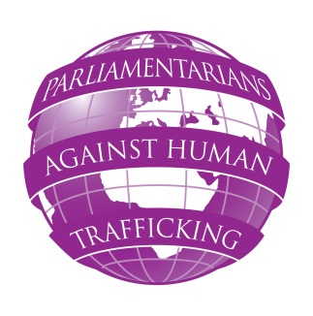
PARLIAMENTARIANS AGAINST HUMAN TRAFFICKING
FRIDAY 15 MARCH 2013
SEMINAR ON REGIONAL CO-OPERATION OF THE POLICE AND TRAFFICKING
Riksdagen, Stockholm, Sweden

Andrakammarsalen Room, Riksdagen, Stockholm
08:30 – 09:20 Registration (refreshments will be provided)
09:20 – 10:00 Opening of the seminar:
Per Erik Gunnar Westerberg MP, Speaker (Swedish Parliament)
Anthony Steen, Chairman (Human Trafficking Foundation)
Johan Linander MP (Swedish Parliament)
Caroline Szyber MP (Swedish Parliament) TBC
10:00 – 10:30 Morning session
Keynote speech: The role of regional cooperation of the police and law enforcement in preventing and combating human trafficking - priorities, tasks and challenges.
Speaker: Anna Ekstedt, Senior Adviser (Council of Baltic Sea States – Trafficking in Human Beings)
10:30 – 11:00 Q & A session
Facilitator: Baroness Butler-Sloss (UK Parliament) TBC
11:00 – 11:30 Coffee break
11:30 – 13:00 Panel discussion on aspects of police cooperation: evidence gathering, work with victims and witnesses of human trafficking
Andre Oktay Dahl TBC (Nordic Council), Heike Rudat TBC (Head of Human Trafficking – Criminal Investigation Department, Berlin, Germany), Maria Stenberg MP (Swedish Parliament)
Facilitator: Johan Linander, MP (Swedish Parliament)
13:00 – 13:45 Buffet lunch
13:45 – 14:45 Parliamentarians’ panel: How can MPs ensure better regional and cross-sector cooperation?
Frank Field MP (UK Parliament), Senator Vanessa Matz (Belgian Parliament), Caroline Szyber, MP (Swedish Parliament), Robert Biedron MP (Polish Parliament)
Facilitator: Angie Bray MP (UK Parliament)
14:45 – 15:15 Q&A session
Facilitator: Helena Karlen, (ECPAT Sweden) TBC
15:15 – 16:00 Countries Overview: Senator Vanessa Matz, (Belgian Parliament)
16:00 Close of seminar

