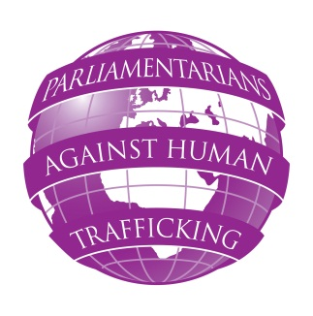
PARLIAMENTARIANS AGAINST HUMAN TRAFFICKING
SEMINAR ON CHILD TRAFFICKING
FRIDAY 18 JANUARY 2013
Congreso de los Diputados, Madrid, Spain
DRAFT AS OF 5/12/2012– SUBJECT TO ALTERATION

Thursday 17 January 2013
British Embassy (TBC) Madrid
19:00 Welcoming reception TBC

Friday 18 January 2013
Congreso de los Diputados, Calle de Fernanflor, Madrid
08:30 – 09:30 Registration of participants (refreshments will be provided)
09:30 Opening of the seminar:
Anthony Steen, Chairman, Human Trafficking Foundation
Marta Gonzalez Vazquez MP (Spain), Commission on Equal Opportunities (TBC)

10:00 – 10:30 Morning session
Keynote speech:
Standards concerning preventing and combating trafficking in children:
recommendations and obligations of the EU member states
Lars Lööf, Head of Children’s Unit Council of the Baltic Sea States
10:30 Q & A session
Peter Bone MP (UK), TBC Chairman, UK All Party Parliamentary Group on Human Trafficking
11:00 Coffee break
11: 20 Practical experiences: two case studies on child trafficking
presented by ECPAT UK and TBC
13:00 – 13:45 Buffet lunch
13:45 – 16:00 Countries Overview:
- Spain
- Belgium
Coffee break
- Estonia
Discussion
Facilitator: Marta Gonzalez Vazquez MP (Spain)
16:00 Close of seminar

