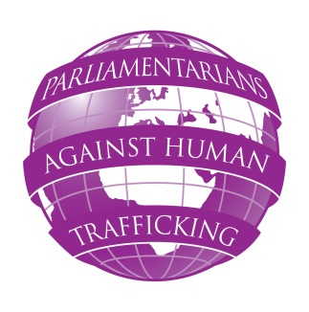
PARLIAMENTARIANS AGAINST HUMAN TRAFFICKING
SEMINAR ON CHILD TRAFFICKING
FRIDAY 18 JANUARY 2013
Congreso de los Diputados, Madrid, Spain

Camera Ernest Lluch, Congreso de los Diputados, Calle de Fernanflor, Madrid
08:30 – 09:20 Registration of participants (refreshments will be provided)
09:20 Opening of the seminar:
Anthony Steen, Chairman, Human Trafficking Foundation
Carmen Quintanilla, Chairman, Equal Opportunities Commission
Sr. Aparicio, Home Affairs Commission
Marta Gonzalez Vazquez MP, Equal Opportunities Commission
10:00 – 10:30 Morning session
Keynote speech:
Standards concerning preventing and combating trafficking in children:
recommendations and obligations of the EU member states
Lars Lööf, Head of Children’s Unit Council of the Baltic Sea States

10:30 Q & A session
Chairman: Peter Bone MP (UK), Chairman, UK All Party Parliamentary Group on Human Trafficking
11:00 Coffee break
11: 20 Practical experiences: two case studies on child trafficking
presented by Colin Walker, ECPAT UK and Colin Carswell, Metropolitan Police Representative (UK)
13:00 – 13:45 Buffet lunch
13:45 – 14:15 How to share and promote the work of the PAHT project in national parliaments
Anthony Steen TBC
Discussion
14:15 – 16:00 Countries Overview:
- Spain – Marta Gonzalez Vazquez MP
- Estonia – Kalle Laanet MP TBC
Coffee break
Discussion
Facilitator: Marta Gonzalez Vazquez MP (Spain)
16:00 Close of seminar

