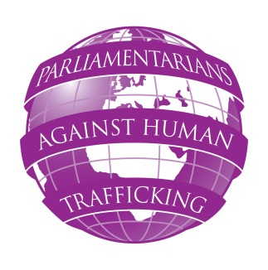
PARLIAMENTARIANS AGAINST HUMAN TRAFFICKING
London Conference – Tuesday 16 and Wednesday 17 October 2012
Draft Programme (as of 19/9/2012)

TUESDAY 16 OCTOBER 2012
13:45 – 14:00 Welcome and opening remarks
Anthony Steen, Chairman, Human Trafficking Foundation
14:00 – 14:30 Rt Hon William Hague MP, Secretary of State, Foreign and Commonwealth Office, United Kingdom
Speech followed by Q&A
14:30 – 15:00 Keynote speech:
An EU Strategy towards the eradication of trafficking in human beings
Christine Beddoe, Director, ECPAT UK
15:00 – 16:00 Progress reports from Parliaments already involved in the project:
- Country TBC
- Lithuania
16:00 – 16:30 Tea break
16:30 – 17:00 Progress reports from Parliaments already involved in the project:
- Country TBC
- Spain
17:00 – 17:30 Guided discussion
- The importance of being open to the involvement of NGOs in parliamentary groups
- What solutions can we find to guarantee MPs’ commitment?
17:30 Finish
WEDNESDAY 17 OCTOBER 2012
09:45 – 10:00 Opening remarks
10:00 – 10:45 Keynote speech:
Maria Grazia Giammarinaro ,OSCE Special Representative and Coordinator for Combating Trafficking in Human Beings
10:45 – 11:00 Evaluation of the first year of the project.
Gary Craig, Project Evaluator
11:00 – 11:10 Presentation and explanation of working groups
11:10 – 13:30 Formation of 4 working groups:
1) The role of other countries in the future of the PAHT network
2) Activities of the second year of the PAHT project and follow up period
3) Identification of the main content areas for PAHT project to focus on
4) Drafting group to prepare draft of final PAHT declaration to be presented during the final Bucharest Conference, June 2013
Tea/coffee available during group work
13:30 – 15:00 Lunch
15:00 – 16:00 Plenary session: Presentation of the results of the working group
16:00 – 16:45 Discussion on results
Led by Maria Grazia Giammarinaro, OSCE Special Representative and Coordinator for Combating Trafficking in Human Beings
16:45 – 17:00 Closing remarks and end of conference

