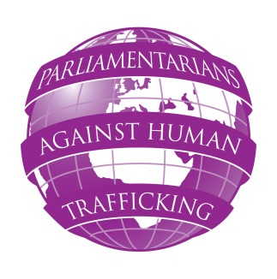
Parliamentarians Against Human Trafficking
Seminar in Lisbon
13-14 September 2012
Assembleia da República de Portugal, Palácio de São Bento

DRAFT – 20/08/2012 – SUBJECT TO ALTERATION

Data Collection, Mapping and Evidence Gathering

Thursday 13 September 2012
13:00 – 14:00 Registration of participants (refreshments will be provided)
14:00 – 14:30 Opening of the seminar,
Maria Cardoso MP, Anthony Steen, Human Trafficking Foundation
14:30 – 15:45 Keynote speech:
Mapping of trafficking – the Portuguese example and how it works in practice.
Manuel Albano, Coordinator of the NAP and National Rapporteur
Q & A session
15:45 – 17:00 Panel discussion:
Why data collection and evidence gathering on trafficking is important for AT efforts?
How MPs could endorse the data collection process in their countries and how they could benefit from it in their parliamentary work.
Discussion led by Klara Skrivankova, ASI
Panellists: Marta Gonzalez, Spain; Caroline Szyber, Johan Linander, Sweden; Maria Paula Cardoso, Portugal.

17:00 – 17:40 Q & A session

17:40 – 18:00 Delegates at leisure

18:00 Depart for British Embassy

18:30 – 20:30 Reception at British Embassy

Friday 14 September 2012
9:00 – 10:00 Evidence gathering and data collection to advocate for changes.
Case study I - ECPAT UK
Christine Beddoe, Director
Case study II – Anti Slavery International
Klara Skrivankova, anti-trafficking coordinator
10:00 – 11:30 Guided discussion
MPs will present examples from their countries and will explore possibilities to use data evidence gathered in the process of reforming law.
11:30 – 12:00 Q & A session
12:00 – 12:30 End of the seminar

