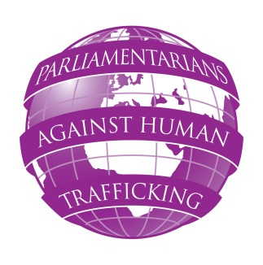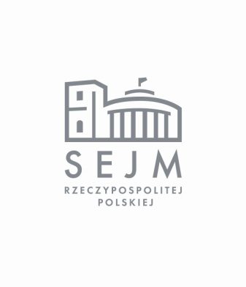
PARLIAMENTARIANS AGAINST HUMAN TRAFFICKING
SEMINAR ON THE NATIONAL REFERRAL MECHANISM
WARSAW, POLAND
WEDNESDAY, 18 APRIL 2012
Tuesday 17 April 2012
17:30 – 19:30 Reception, British Embassy
Hosted by HMA Robin Barnett, British Ambassador to Poland

Wednesday 18 April 2012
Sejm of the Republic of Poland, Wiejska street 4/6/8, Warsaw
Deputies Hotel (Conference Room)
9:00 – 9:30 Registration of participants
9:30 – 10:30 Welcome and introduction
Wanda Nowicka, Deputy Marshal of the Sejm of the Republic of Poland (TBC)
Ryszard Kalisz MP, Chairman of the Justice and Human Rights Committee
HM Ambassador Robin Barnett, British Ambassador to Poland
Anthony Steen, Human Trafficking Foundation, UK

10:30 – 11:20 Keynote speeches:
- How the National Referral Mechanism contributes to better protection and assistance to victims of trafficking?
Mariana Katzarova, Senior Advisor on Anti-Trafficking Issues ODIHR/OSCE
- What role can MPs play to ensure the effective functioning of the NRM in their countries?
Parliamentary keynote speaker - TBC
11:20 – 11:50 Coffee break
11:50 – 13:30 How can parliamentarians build up parliamentary groups as part of an EU parliamentary network?
Countries overview: What has been done thus far in order to establish awareness of parliamentary groups in the Parliaments of participating countries?
Panellists - MPs from Bulgaria, Czech Republic, Denmark, Estonia, Latvia, Lithuania, Poland, Romania, Slovenia, UK.
Panel discussion followed by Q&A session
Panel Discussion Chair: Baroness Elizabeth Butler-Sloss, Human Trafficking Foundation, UK
13:30 – 14:30 Lunch break
14:30 – 16:00 Co-operation between different stakeholders - NGOs and law enforcement representatives in referral of victims of trafficking
Mr Piotr Mierecki, Director of Department of Migration Policy, Ministry of the Interior; representative of the Police, Prosecutor Office , Irena Dawid-Olczyk –KCIK, National Consulting and Intervention Centre for the Victims of Trafficking; Piotr Boćko, Border Guards; Other panellists to be confirmed
Chair: Stana Buchowska, PAHT, ECPAT UK
16:00 – 16:30 Conclusions of the meeting
Stana Buchowska, Project Co-ordinator
End of the seminar

