PARLIAMENTARIANS AGAINST HUMAN TRAFFICKING
WARSAW SEMINAR – WEDNESDAY 18 APRIL 2012
PRACTICAL INFORMATION NOTE

PROGRAMME
A copy of the draft programme is attached. An updated version of the programme will be circulated in due course.
HOTEL
A reservation has been made for you for the night of Tuesday 17 April 2012 at the following hotel:
Sheraton Hotel
Boleslawa Prusa 2 · Warsaw 00-493 · Phone (48) (22) 450 6100
Bed, breakfast and taxes will be paid by the PAHT team. All additional charges (e.g. laundry, internet) should be settled separately at the hotel reception.

YOUR FLIGHT
Details of your flights, together with e tickets, will be sent to you in a separate email.
Your flight has been paid for by the PAHT team.
IMPORTANT – PLEASE RETAIN BOARDING CARDS FOR YOUR FLIGHTS AND RETURN TO THE PAHT TEAM.

DAILY SUBSISTENCE ALLOWANCE
Non-domestic participants are eligible to receive a daily subsistence allowance (DSA) to cover costs associated with participation in the seminar. Namely, these include transfer from home to the airport, local transport in Poland and meals not provided directly by the seminar.
For the seminar, the DSA issued will be €80.
Participants will receive their DSA at the start of the seminar, upon receipt of the boarding pass for their outward flight.

DIRECTIONS
TO THE HOTEL FROM WARSAW AIRPORT
The easiest option is to take a taxi from the front of the terminal – this should cost approximately €6. The journey should take roughly 30 – 40 minutes. A map showing the location of the hotel is below.
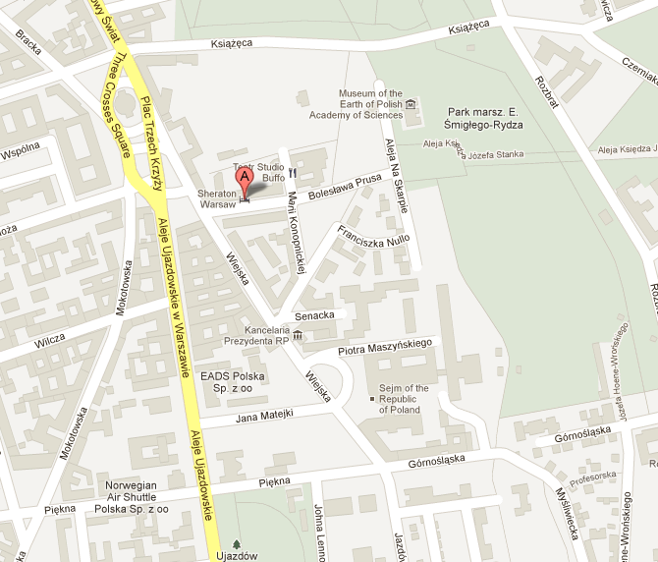

FROM THE HOTEL TO THE RECEPTION VENUE
The reception will be held on the evening of Tuesday 17 April from 5.30pm to 7.30pm at the British Ambassador’s Residence, Warsaw. The address of the residence is:
Warszawa ul. Seweryna Goszczyńskiego 27
Taxis will be provided and paid for for participants staying at the hotel to travel to the reception venue. Please gather in the hotel lobby from 5pm. Taxis should be ordered at the reception desk, please quote ‘ECPAT UK’. Only taxis ordered from the hotel reception desk will be paid for by the project.
A map showing the residence is below:
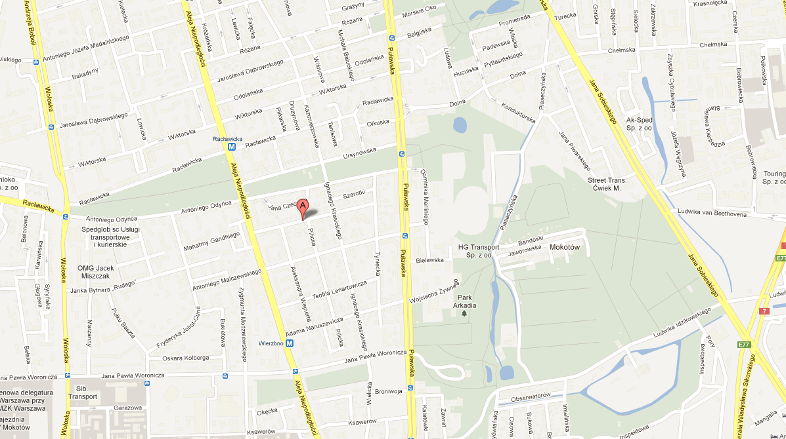

FROM THE HOTEL TO THE SENATE
The address of seminar venue is:
Sejm
ul. Wiejska 6/8 - 00 902 WARSZAWA

The seminar venue is very close to the hotel, 5-10 minutes walk.Please see map below.

