PARLIAMENTARIANS AGAINST HUMAN TRAFFICKING
ROME SEMINAR – THURSDAY 22 MARCH 2012
PRACTICAL INFORMATION NOTE

PROGRAMME
A copy of the draft programme is attached. An updated version of the programme will be circulated in due course.
HOTEL
A reservation has been made for you for the night of Wednesday 21 March 2012 at the following hotel:
Leon’s Place Hotel
LEON'S PLACE HOTEL IN ROME
Via XX Settembre 90/94
00187 Rome
Italy
Bed, breakfast and taxes will be paid by the PAHT team. All additional charges (e.g. laundry, internet) should be settled separately at the hotel reception.

YOUR FLIGHT
Details of your flights, together with e tickets, will be sent to you in a separate email.
Your flight has been paid for by the PAHT team.
IMPORTANT – PLEASE RETAIN BOARDING CARDS FOR YOUR FLIGHTS AND RETURN TO THE PAHT TEAM.

DIRECTIONS
TO THE HOTEL FROM FIUMICINO AIRPORT
From Fiumicino Airport, take the Leonardo Express train to Roma Termini station. The train departs every 30 minutes (at xx:22 and xx:52) and takes approximately 30 minutes.Tickets cost €14 each way. The hotel is approximately 15 to 20 minutes walk from Termini station. A map is provided below.
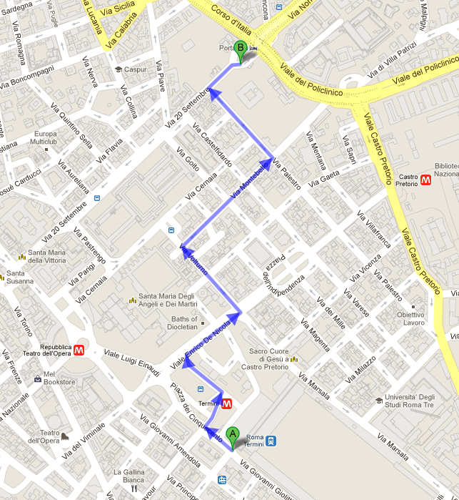

FROM THE HOTEL TO THE SENATE
The address of seminar venue is:
Senato della Repubblica
Palazzo Madama
00186 ROMA

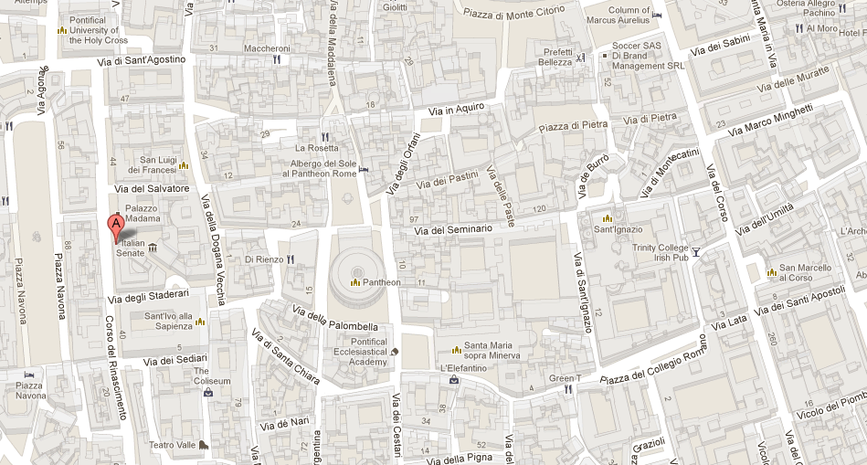

A bus transfer will be provided for participants from the hotel to the Senate and will depart at 8.45am on Thursday 22 March.

DAILY SUBSISTENCE ALLOWANCE
Non-domestic participants are eligible to receive a daily subsistence allowance (DSA) to cover costs associated with participation in the seminar. Namely, these include transfer from home to the airport, local transport in Italy and meals not provided directly by the seminar.
For the seminar, the DSA issued will be €90.
Participants will receive their DSA at the start of the seminar, upon receipt of the boarding pass for their outward flight.

