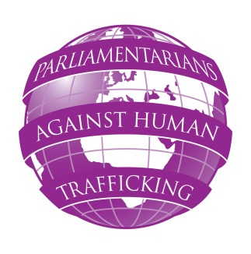
PARLIAMENTARIANS AGAINST HUMAN TRAFFICKING
GOOD PRACTICE EXCHANGE
THE HAGUE, NETHERLANDS
THURSDAY 26 JANUARY 2012

Wednesday 25 January 2012
Carlton Ambassador Hotel, The Hague
Sophialaan 2 - 2514 JP The Hague - The Netherlands
19:00 – 20:00 Networking reception
Thursday 26 January 2012
Eerste Kamer der Staten-Generaal, Parliament of the Netherlands, The Hague
Binnenhof 22 - P.O. Box 20017 - 2500 EA Den Haag
8:30 – 9:00 Registration of participants
9:00 – 9:30 Welcome and introduction
Senator Willem Bröcker, The Netherlands Anthony Steen, Human Trafficking Foundation, UK
9:30 – 10:30 Keynote speech:
- The National Rapporteur on Trafficking in Human Being. The Dutch experience. How the NR might enhance work of MPs? Ms Corinne Dettmeijer-Vermeulen, Dutch National Rapporteur on Trafficking in Human Beings

- How MPs could benefit from the Office of the National Rapporteur: The Dutch Parliamentarians’ Experience.
Ard Van Der Steur MP, The Netherlands
10:30 – 11:00 Coffee break
11:00 – 13:00 How can parliamentarians build up parliamentary groups as part of an EU parliamentary network? Panellists: Elisabeth Naucler MP (Finland), Maria Cardoso MP (Portugal), Athanassios Alevras MP (Greece), Robert Biedron MP (Poland), Ard Van Der Steur MP (Netherlands), Senator Maritati (Italy), Peter Bone MP (UK), Lord McColl (UK), Anna Lo MLA (UK), Michael Connarty MP (UK)
Panel discussion followed by Q&A session
Panel Discussion Chair: Mr Florin Paslaru MP, Romania
13:00 – 14:30 Lunch break
14:30 – 15:30 Countries overview: What has been done thus far in order to establish awareness of parliamentary groups in the Parliaments of participating countries?
Panellists: Elisabeth Naucler MP (Finland), Maria Cardoso MP (Portugal), Athanassios Alevras MP (Greece), Robert Biedron MP (Poland), Ard Van Der Steur MP (Netherlands), Senator Maritati (Italy), Lord McColl (UK), Anna Lo MLA (UK), Michael Connarty MP (UK), Florin Paslaru MP (Romania)
Chair: Peter Bone MP, Co-Chair, APPG on Human Trafficking

15:30 – 16:00 Co-operation between NGOs and the National Rapporteur office on anti -trafficking activities
Sandra Classen (Blinn), Bas De Visser (Comensha), Theo Noten (ECPAT Netherlands), Jaana Kauppinen (Pro Centre Finland)
Presentation by NGOs and discussion
Chair: Marieke van Dorninck, La Strada International
16:00 – 16:30 Evaluation of the meeting
16:30 – 17:00 Conclusions and follow-up plans
By Anthony Steen, Chairman, Human Trafficking Foundation
Christine Beddoe, Director, ECPAT UK
Stana Buchowska, Project Co-ordinator
End of the seminar

